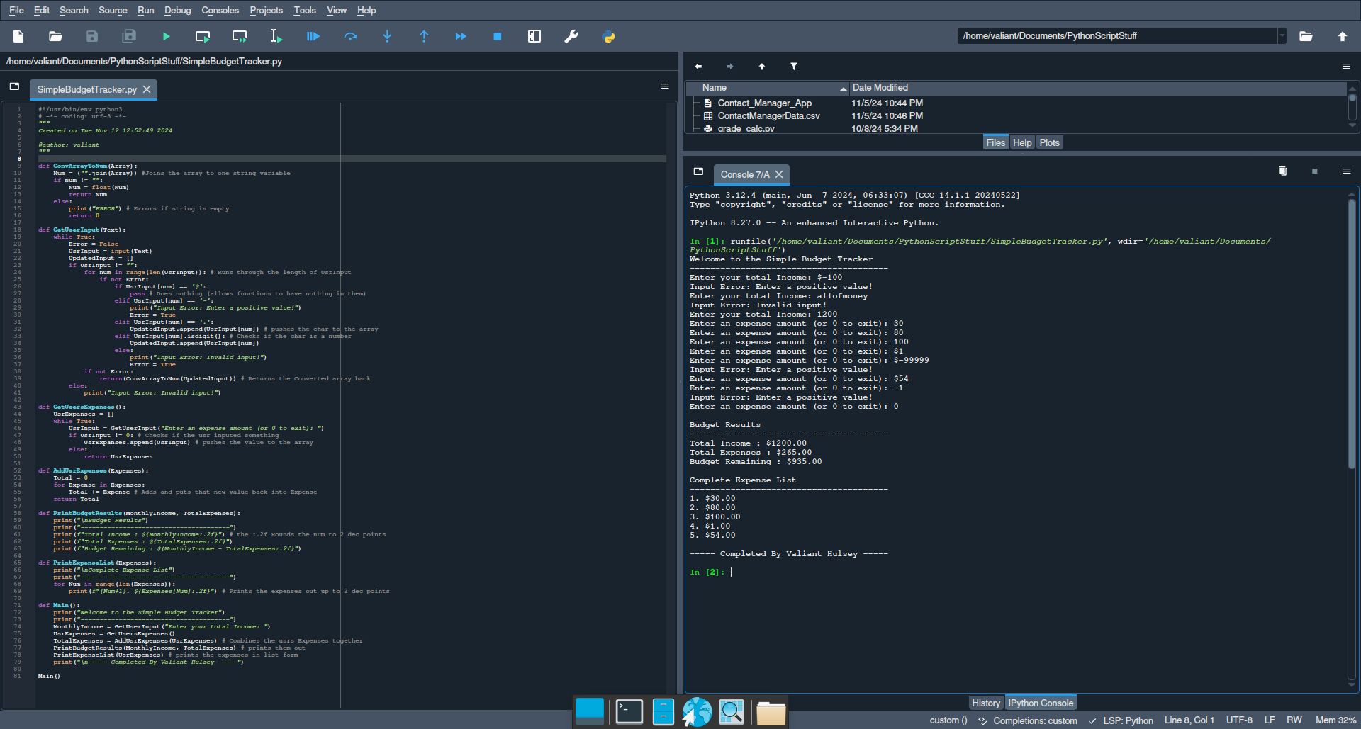(Might Need to shrink the image)

#!/usr/bin/env python3

# -*- coding: utf-8 -*-

"""

Created on Tue Nov 12 12:52:49 2024

@author: valiant

"""

def ConvArrayToNum(Array):

Num = ("".join(Array)) #Joins the array to one string variable

if Num != "":

Num = float(Num)

return Num

else:

print("ERROR") # Errors if string is empty

return 0

def GetUserInput(Text):

while True:

Error = False

UsrInput = input(Text)

UpdatedInput = []

if UsrInput != "":

for num in range(len(UsrInput)): # Runs through the length of UsrInput

if not Error:

if UsrInput[num] == '$':

pass # Does nothing (allows functions to have nothing in them)

elif UsrInput[num] == '-':

print("Input Error: Enter a positive value!")

Error = True

elif UsrInput[num] == '.':

UpdatedInput.append(UsrInput[num]) # pushes the char to the array

elif UsrInput[num].isdigit(): # Checks if the char is a number

UpdatedInput.append(UsrInput[num])

else:

print("Input Error: Invalid input!")

Error = True

if not Error:

return(ConvArrayToNum(UpdatedInput)) # Returns the Converted array back

else:

print("Input Error: Invalid input!")

def GetUsersExpenses():

UsrExpanses = []

while True:

UsrInput = GetUserInput("Enter an expense amount (or 0 to exit): ")

if UsrInput != 0: # Checks if the usr inputed something

UsrExpanses.append(UsrInput) # pushes the value to the array

else:

return UsrExpanses

def AddUsrExpenses(Expenses):

Total = 0

for Expense in Expenses:

Total += Expense # Adds and puts that new value back into Expense

return Total

def PrintBudgetResults(MonthlyIncome, TotalExpenses):

print("\nBudget Results")

print("---------------------------------------")

print(f"Total Income : ${MonthlyIncome:.2f}") # the :.2f Rounds the num to 2 dec points

print(f"Total Expenses : ${TotalExpenses:.2f}")

print(f"Budget Remaining : ${MonthlyIncome - TotalExpenses:.2f}")

def PrintExpenseList(Expenses):

print("\nComplete Expense List")

print("---------------------------------------")

for Num in range(len(Expenses)):

print(f"{Num+1}. ${Expenses[Num]:.2f}") # Prints the expenses out up to 2 dec points

def Main():

print("Welcome to the Simple Budget Tracker")

print("---------------------------------------")

MonthlyIncome = GetUserInput("Enter your total Income: ")

UsrExpenses = GetUsersExpenses()

TotalExpenses = AddUsrExpenses(UsrExpenses) # Combines the usrs Expenses together

PrintBudgetResults(MonthlyIncome, TotalExpenses) # prints them out

PrintExpenseList(UsrExpenses) # prints the expenses in list form

print("\n----- Completed By Valiant Hulsey -----")

Main()